**Summary**

The Magdalena fire station roof receives 3,000 gallons of water with every inch of rainfall. Capturing and storing this water would provide a working and backup water supply to both the fire department and the community, particularly desirable resources in view of the uncertainty of the permanent reliability of both groundwater supply and rainfall. It would also set a conspicuous example of foresight and conservation to the community and its visitors. This proposal describes the installation of 16,800 gallons of rainwater tank storage capacity at the Magdalena fire station, the preparation of village land adjacent to the station on the north side for use as a rainwater-irrigated community garden and orchard, and the projected costs of and sources of funding for these improvements.

**Background**

The arid western U.S. faces a severe water deficit today and in coming years. The village of Magdalena experienced two years ago, as the Water Event, a taste of the consequences of overdrawing its groundwater account, and still has produced no explanation for having run out of water. Nor have residents any reason to trust that there exist unlimited reserves of groundwater to support their consumption, that ample rainfall will recharge these reserves, or that no shortage will recur.

A sensible course of action by residents would be 1) to use groundwater frugally and wisely, 2) to reuse all water as many times as possible, and 3) to capture the free and pure water that falls from the sky. But few Magdalena residents appear to practice any of these measures, and the village's per capita water consumption has returned to near its level preceding the Event. Residents may now believe that having three wells sucking from the aquifer in place of only the one well that failed two years ago provides water security. This bet is a dubious one.

For fire safety alone, it is wise to maintain a supply of water independent of a lone municipal pumping system. Thus, the fire departments of small communities such as Hop Canyon and Pie Town maintain water tanks, filled by pumping groundwater. Should Magdalena's pumping and distribution system or water supply fail, the only water now available for fire emergencies is stored in the fire trucks and amounts to 4000 gallons, an amount quickly discharged onto a house or large brush fire.

The 4875-ft2 steel roof of the Magdalena fire station receives more than 3000 gallons of water with every inch of rain. A year with 8" of precipitation will deliver more than 24,000 gallons. All of this water can be captured with guttering and tanks. It is unnecessary and undesirable to size the storage capacity to the total precipitation if the water is also being used as it is captured; a typical capacity is ½ to 2/3 of the water received. But because there will not be a constant drawdown by firefighting or training use, merely collecting all of the rainfall will lead to overflow and waste. Accordingly, planning other uses for this abundance of water is advisable.

One contingency use is as a source of nonpotable water for residents in future water emergencies, but these, like fires, are rare and unpredictable events. A more stable use is for irrigation. The village land immediately adjoining the fire station's concrete apron on the north is unused. It lies downslope of the station and receives runoff from both the station apron and the area to the west. Both this water, if harvested by simple land forming, and excess water from the station roof could be used for irrigating a community garden and small orchard on this land. The largest portion of rainfall arrives during the summer season of highest irrigation demand, allowing prudent allocation of the water so that a firefighting reserve is always maintained.

Next is described the proposed rainwater capture system and the construction and management of the proposed community garden.

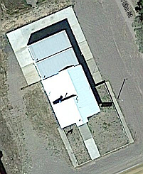**Proposed plan**

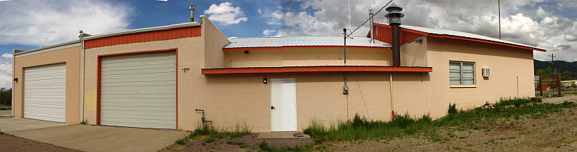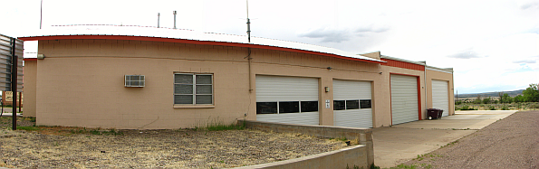An overhead view of the fire station is shown at right, with north at top. The concrete apron to the N is 20' wide and captures 1000 gal of water in 1" of rain. Below are panoramic E and W-side views of the station, for reference against the ground plan at bottom.



The table at top right of the plan describes the amounts of water received and stored with 8" of rainfall. The polyethylene tanks are rated for potable water, although potability is not a goal of this project. Aside from installation of guttering and downspouting, only minor site preparation will be needed. No concrete bases need be poured; for all but the larger northern tank, which will sit directly on the apron, ground preparation will consist of leveling the ground and removing sharp gravel, then covering with 2" of crusher fines or sand.

*Fire use of captured rainwater*

The 6000-gal tank at the N end of the station will be the source of water for all fire use; however, all tanks will be equipped with bulkheads accommodating 3" hose connections for rapid pumping, and with reducing fittings for more low-volume uses. A minimum of 10,000 gal among all tanks will be kept in storage at all times exclusively for fire service use and a minimum of 4,000 gal in the large tank. These volumes will be quickly reached with the first 4" of the first monsoon. Simple float systems will be installed for estimating tank contents (which are also easily estimated from a knock on the side of the tank) and a rain gauge will track precipitation.

A water committee will be elected from among the members of the Magdalena Fire Department and charged with inspecting and maintaining the system, monitoring water levels, and approving water use requests. An example of the latter is in the event of a water event, where allocation of surplus water between the community garden and more urgent uses must be decided.

A pumping system for transferring water among tanks will be installed, using equipment already available at the station. The most common use for this system will be to pump from the smaller tanks to the larger one, which will be used for both emergency fire supply and irrigation, as described next.

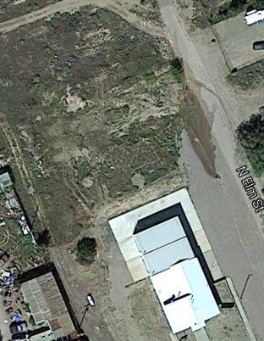*Nonfire use of captured rainwater*

Land preparation

The plot of land to NNW of the fire station, belonging to the village and shown at right, measures about 120' × 180' and descends unevenly to the NNW, with a rough terrace 50' wide parallel to the north edge of the station apron. With the approval of the village and after advance checking for buried utility lines, construction waste and large rocks will be moved from an 80' × 80' square, leaving it level or slightly graded to the slope of the land. Two or three shallow ditches ("swales") will be formed on the contour (across the slope, parallel to the apron edge) to impede erosion from water originating as direct rainfall and runoff from the apron, and will terminate in basins. Garden beds will be laid out for use by village residents. Seedling trees from the NM Forestry Department will be planted around the edge of the square and some fruit trees purchased from nurseries may also be planted. Water from the apron will be guided into the swales and terminal basins for infiltration into the soil.

Water use for irrigation

A system of drip lines will be installed to lie on the surface of the ground. It will be easily moved aside for cultivation and easily drained in the fall. For irrigation, a line will be connected to the outlet of the large N tank, which will provide up to 15' of head pressure.

Management of community garden

Irrigation and general supervision will be the responsibility of a garden manager, who will be a volunteer from among the gardeners or the fire crew. A community garden committee will be formed to oversee the use of the plot and decide on policy such as land preparation and fertilization, provision of mulch, charging of a season use fee for plots, and irrigation matters.

**Costs and funding**

The costs of the tanks, shown in the plan on page 2, are taken from one of the suppliers and are current as of the date of this proposal. Delivery will add a few percent to this cost. Installing fittings for tank inflow and outflow will also add < $200. Site preparation can be done, and guttering installed, by the fire crew, although the tank contractor may also offer this service. Other tank options will be evaluated, as different dimensions, volumes, and tank materials are available, but the cost in the example is in the neighborhood of the final projected cost.

Water storage facility construction is a permitted use of fire funds, and the Magdalena fire chief has expressed his readiness to obtain the approval of the state fire marshal as well as the Village for this use. Because a component of this proposal is the nonfire use of some of the captured rainwater, it is proposed to seek third-party funding for part of the cost. The stipulation described above of a minimum amount to be kept available for firefighting activities is made with the intention of satisfying the fire marshal that the fire funds are being properly used.

The village will be requested to furnish equipment and an operator for initial land preparation, but rarely if ever thereafter. The costs of irrigation line and trees will be covered by the third-party grant or by donations from residents and garden use fees. Yearly cultivation and/or fertilization and fencing and land maintenance will be arranged by the garden management committee.

The writer of this proposal, a Magdalena resident and volunteer firefighter, with the support of the Magdalena fire chief and letters of support solicited from interested community members, will prepare proposal materials for the state fire marshal's office and will solicit matching or contributory funds from local corporate businesses such as Wells Fargo Bank and Family Dollar. The MFD may also hold events such as bake sales to inform and invite participation by community members as well as build a maintenance fund for the garden.

**Wider significance**

As suggested above, water-conservation measures are not a prominent part of the lives of village residents, or indeed of most Americans. The conspicuous model of careful rainwater harvesting represented by this installation, visible to all who drive through the village on the main E–W highway as well as to all residents, will set a compelling example of a village that takes seriously its own precarious water situation and, by extension, that of the arid West. One of many ways to emphasize the message would be to paint the tanks with colorful murals, such as large water droplets. The rainwater-capture system and community garden could be a prominent stop on the village tours organized around art crawls, library presentations and performances, and yard sales. Visitors could be presented with plans such as the one on page 2, showing how a water harvesting system can be designed for a medium-size building. The message will be that we are doing it and so can you. Magdalena may be known for its dark skies, mining and cattle-driving history, arts and crafts, and natural scenery, but marketing these assets won't promote any change in visitors' conservation behavior. The village could also become known for the environmental conscience and actions of its residents, and that reputation could help effect such a change. Future projects in our village whose description is beyond the scope of this proposal could address surface water management, material recycling, and renewable energy substitution, all with the same purpose: to address, and show ways to address, the water, energy, and other resource threats that face all of us.